## DATE:

## EXPERIMENT: 20

**IMPLEMENTATION OF IOT BASED SMART GARDENING**

**Aim:** To implement IOT based smart gardening using Cisco packet tracer.

**Software/Apparatus required:** Packet Tracer/End devices, Hubs, Connectors.

**Procedure:**

Step 1: Create a new project in Cisco Packet Tracer and drag a generic IoT device from the IoT devices section onto the workspace.

Step 2: Right-click on the IoT device and select Config/Attributes.

Step 3: In the Configuration tab, select the device's IoT server from the drop-down list. You can choose Cisco IoT Cloud or another cloud service of your choice.

Step 4: In the Attributes tab, add the following attributes:

* Temperature
* Humidity
* Soil Moisture
* Light Intensity

Step 5: Create a soil moisture sensor and a light sensor from the Sensors section of the devices panel.

Drag and drop these sensors onto the workspace.

Step 6: Connect the sensors to the IoT device using the wiring tool.

Step 7: Configure the sensors by right-clicking on them and selecting Config/Attributes. Set the sensor type, unit of measurement, and other necessary parameters.

Step 8: Create a water pump and a light bulb from the Actuators section of the devices panel. Drag and drop these actuators onto the workspace.

Step 9: Connect the actuators to the IoT device using the wiring tool.

Step 10: Configure the actuators by right-clicking on them and selecting Config/Attributes. Set the actuator type, command, and other necessary parameters.

Step 11: Save the configuration and run the simulation to test your IoT Smart Garden.

Step 12: Monitor the temperature, humidity, soil moisture, and light intensity readings on the IoT device dashboard.

Step 13: Use the dashboard to control the water pump and light bulb based on the sensor readings.

**OUTPUT:**

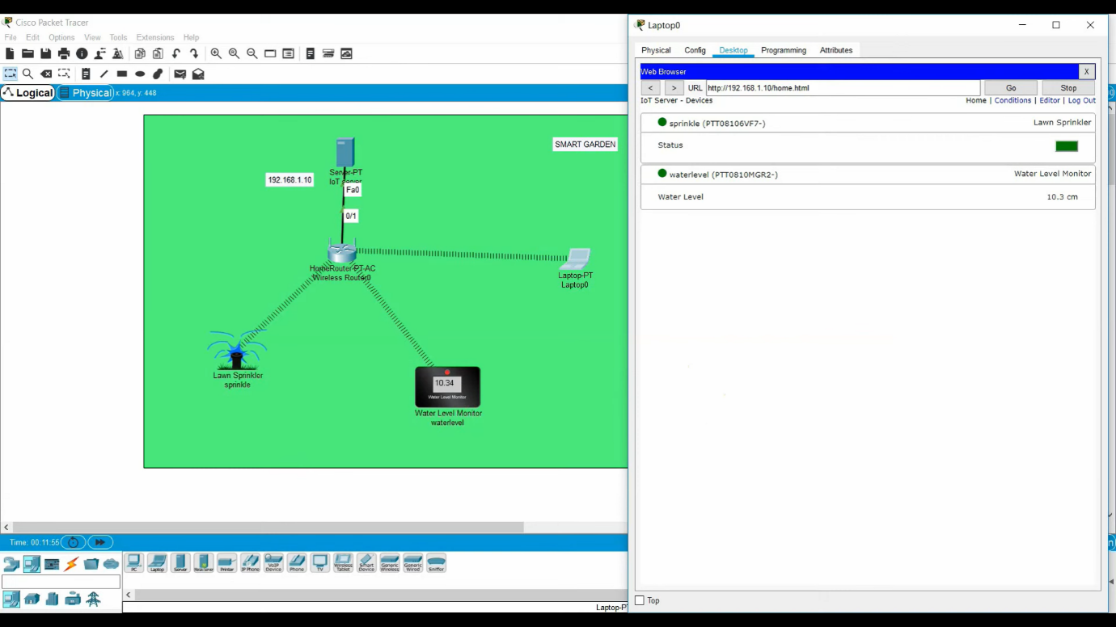

**Result:** Implementation of smart gardening is carried out using IOT successfully.